MEETING MINUTES
SOUTHEAST MICHIGAN REGIONAL TRANSPORTATION OPERATIONS
PLANNING SUBCOMMITTEE

Date: February 12, 2015
Time: 9:00 AM
Meeting Held: Southeast Michigan Transportation Operations Center, Detroit

Present: Representing Phone No. E-Mail

Dayo Akinyemi………. …MDOT - SEMTOC…....(313) 256-9802…………AkinyemiO@michigan.gov
Sarah Gill……….. .... … ...MDOT-SEMTOC.…… (248) 867-6841…………………gills@michigan.gov
Dawn Miller…… ……….MDOT-Lansing….…… .(517) 636-4719……………..millerd2@michigan.gov
Craig Shackleford…… Bloomfield Twp. Police .. (248) 433-7749 ……….cshackleford@bloomfiedtwp.org
Tom Bruff…….. …..……… SEMCOG…….... (313) 324-3340.…....................bruff@semcog.org
Kim Comerford…...Bloomfield Twp. Police.……..(248) 433-7749……..kcomerford@bloomfieldtwp.org
Jeff Young……………….Washtenaw Co. RC…….(734) 327-6671………………youngj@wcrcroads.org
Jim Santillli………………Traffic Imp. Assn………(248) 334-4971……………..……jsantilli@tiami.org
Richard Beaubien Beaubien Engineering ..(248) 515-3628 …rfbeaubienpe@gmail.com

Review of Meeting Agenda for the Southeast Michigan Regional Transportation Operations Coordinating Committee Meeting
The April 17, 2015 Regional Transportation Operations Coordinating Committee meeting will be held at the Southeast Michigan Transportation Operations Center (SEMTOC), 1060 West Fort Street, Detroit, Michigan 48226. Potential topics will include regional transportation operations goals and objectives, transit system fare integration, freeway operations, and a review of statewide traffic incident management activities.

Plans for 2015 Partnering Workshop
The workshop is scheduled for March 6, 2015 at the Oakland County Executive Office Building. The program will include at Mi-TIME update, an after action review of the Southfield Freeway closure after the pedestrian bridge hit, a discussion of the new Michigan “hold harmless” law, a traffic incident management training module from the fire service view, and a presentation on evacuation, mass care and shelter services support. Oakland County Executive L. Brooks Patterson has been confirmed as the kickoff speaker at the workshop.

Reggie Washington from MDOT will organize the after action review, and Mike Shaw from Michigan State Police will be invited to participate on the panel. Both MDOT video and broadcast media video of this incident may be available to stimulate and inform the discussion. MDOT will provide copies of the After Action Report as a resource for panel members. Other players involved in the incident included Wayne County Roads, emergency medical services, towing services a contractor to remove the fallen bridge, and SEMTOC dispatch. The contractor who removed the fallen pedestrian bridge will be invited to be part of the panel.

Interaction between the panel members and the audience will be encouraged. Questions such as, “what did we learn?” and “how might we do it better next time?” will likely be posed to the panel to encourage spontaneous discussion. Jim Santilli and the Traffic Improvement Association will arrange for a light breakfast and a lunch. MDOT will provide a photographer. Tom Bruff at SEMCOG will propare a program for the meeting with information on the speakers, and he will collect the presentation material from the speakers.

Next Planning Subcommittee Meeting
The next meeting for the Planning Subcommittee has been scheduled for 9:00 AM on March 19, 2015 at SEMTOC.

These minutes are intended to be a summary of those items discussed. Any corrections and/or comments should be noted to the writer as soon as possible.

Respectfully submitted,

BEAUBIEN ENGINEERING

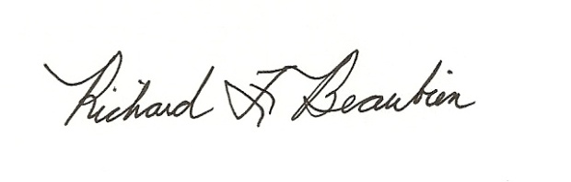
Richard F. Beaubien, P.E., PTOE
Chair-Southeast Michigan Regional Transportation Operations Coordinating Committee

pc: All present

