MEETING MINUTES
SOUTHEAST MICHIGAN REGIONAL TRANSPORTATION OPERATIONS
PLANNING SUBCOMMITTEE

Date: November 14, 2013
Time: 9:00 AM
Meeting Held: Macomb County Department of Roads, Mt. Clemens, MI

Present: Representing Phone No. E-Mail
Oladayo Akinyemi MDOT - SEMTOC (313) 256-9802 AkinyemiO@michigan.gov
Tom Bruff ………… SEMCOG…… . (313) 324-3340 ……………………bruff@semcog.org
Morrie Hoevel FHWA (517) 702-1834 Morris.Hoevel@dot.gov
Craig Shackleford…… Bloomfield Twp. Police (248) 433-7749 …….cshackleford@bloomfiedtwp.org
Laurie Thiel…………..One Hour Consult…....(586) 244-2126…………...lauriethiel586@gmail.com
Phil Wagner…………. Westshore Fire ……..(734) 476-2360 ……….pwwagner@charter.net
Russ Kudela……………...Macomb Roads……(586) 463-5671 rkudela@rcmcweb.org
Richard Beaubien Beaubien Engr (248) 515-3628 rfbeaubienpe@gmail.com

Review of Meeting Agenda for the Southeast Michigan Regional Transportation Operations Coordinating Committee Meeting
The January 10, 2014 Regional Transportation Operations Coordinating Committee meeting will be held at the Southeast Michigan Transportation Operations Center (SEMTOC), 1060 West Fort Street, Detroit, Michigan 48226. Potential topics include a presentation on the AAA Tow Service program, a review of progress on 2013 goals and objectives led by Tom Bruff, a report on Arterial Traffic Management, freeway operations, and a review of statewide traffic incident management activities.

2014 Meeting Schedule
A proposed committee and subcommittee meeting schedule was reviewed and revised to avoid conflicts with other traffic operations activities. A copy is attached.

Plans for Partnering Workshop in March 2014
The desired location for the 2014 Regional Transportation Operations Partnering Workshop in March 2014 is the Macomb Intermediate School District facility. We would hope that both County Executive Mark Hackel and Emergency Operations Manager Vicki Wolber would be available to explain the planning and operation of the new center. Sheriff Wickersham and County Highway Engineer Hoepner could be on a panel discussing how traffic cameras, sheriff dispatch, and emergency management operate in an integrated fashion.

Other potential topics to include in the program included the Mutual Aid Box Alarm system, and the I-696 and I-75 Integrated Corridor Management projects. Laurie Thiel will recommend a speaker to discuss the role of Emergency Medical responders. The program, or a portion of it, could broadcast to Detroit area fire stations via video conference. Because the Operations Center is limited to 50 attendees, we will try to arrange to use the Macomb Intermediate School District facilities for the presentations and offer tours of the Operations Center after lunch. During workshop registration, tour times could be assigned, and maps to the Operations Center could be distributed.

SEMCOG will arrange for the preparation of the program and the collection of speaker biographies and presentations. MDOT will arrange for a photographer.

Hold Harmless Legislation
MDOT has drafted a bill to be considered by the legislature, and the draft is circulating for comments. .

Next Planning Subcommittee Meeting
The next meeting for the Planning Subcommittee has been scheduled for 2 PM on December 12, 2013 at the Southeast Michigan Transportation Operations Center. It will focus March 2014 Partnering Workshop in Macomb County These minutes are intended to be a summary of those items discussed. Any corrections and/or comments should be noted to the writer as soon as possible.

Respectfully submitted,

BEAUBIEN ENGINEERING

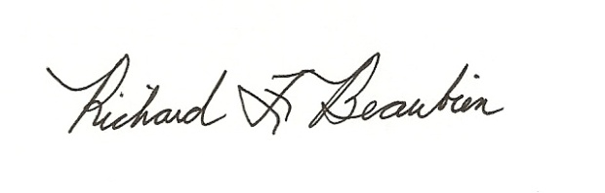
Richard F. Beaubien, P.E., PTOE
Chair-Southeast Michigan Regional Transportation Operations Coordinating Committee

pc: All present

