MEETING MINUTES
SOUTHEAST MICHIGAN REGIONAL TRANSPORTATION OPERATIONS
PLANNING SUBCOMMITTEE

Date: February 13, 2013
Time: 9:30 AM
Meeting Held: Macomb County Department of Roads, Mt. Clemens, MI

Present: Representing Phone No. E-Mail
Oladayo Akinyemi MDOT SEMTOC (313) 256-9800 AkinyemiO@michigan.gov
Belinda Beard ………… ITS Michigan………. (313) 202-1163 …………………beard@pbworld.com
Tom Bruff SEMCOG (313) 324-3340 bruff@semcog.org
Morrie Hoevel FHWA (517) 702-1834 Morris.Hoevel@dot.gov
Craig Shackelford…… Bloomfield Twp. Police (248) 433-7749 …….cshackelford@bloomfiedtwp.org
Rick Leonard…………….Auburn Hills Police .. (248) 364-6854 …….……….rleonard@auburnhills.org
Richard Beaubien Beaubien Engr (248) 515-3628 rfbeaubienpe@gmail.com

Review of Meeting Agenda for the Southeast Michigan Regional Transportation Operations Coordinating Committee Meeting
The April 5, 2013 Regional Transportation Operations Coordinating Committee meeting will be held at the new Southeast Michigan Transportation Operations Center (SEMTOC), on Fort Street, immediately south of the current MITSC building, Detroit, Michigan 48226. Potential topics include a presentation on Integrated Corridor Management, a review of the TIM Workshop, new technology for emergency responders, a review of the I-75/Springwells triple fatality incident, status of the MDOT emergency response vehicle, and a review of statewide traffic incident management activities. It will also include a review of freeway operations issues.

March Partnering Workshop
The Annual Traffic Incident Management Workshop is scheduled for March 7, 2013 at the Southeast Michigan Transportation Operations Center. Dayo Akinyemi indicated that the attendance in his facility will be limited to 110 people. The program will include:

- Tour of the Southeast Michigan Transportation Operations Center
- Presentation by Michigan State Police on their regional dispatch operation
- Presentation on the Freeway Courtesy Patrol
- Presentation on Medical Examiner Quick Clearance Issues
- Presentation by Macomb County Executive Mark Hackel on the County Emergency Operations Center
- Fire Service Incident Command for the I-696/Halstead tanker rollover
- Presentation by Angie Kremer on Traffic Incident Management Training and Highway Safety Planning.
Registration for the workshop will be available on the ITS Michigan website. An announcement of the workshop should be sent to the SE Michigan Fire Chiefs, American Public Works Association, ITS Michigan, Institute of Transportation Engineers, and Medical Examiners. SEMCOG will prepare the workshop agendas and handout information. Each presentation should have a theme. Speakers will be asked to address the question, “What can we improve in the future?” Belinda Beard will arrange for continental breakfast and box lunch service. Dayo Akinyemi will arrange for the rental of round tables. Dayo Akinyemi will arrange for table rental. The estimated table cost rental is $250.

The lunch presentation by Erin Nicole is scheduled for 12:30 PM, and control room tours will be available beginning at 1:00 pm. Tom Bruff will bring a laptop with all of the presentations for visual displays provided by the presenters. During breaks, participants will be asked to set priorities for TIM activities during the next year. A conference call to finalize the March 7 Workshop will be held at 9AM on March 1, and it will be organized by Belinda Beard.

Hold Harmless Legislation
MDOT staff is preparing a “white paper” to explain the need for this legislation and what other states have done in this area. The Planning Committee felt that it should apply to all roads rather than just MDOT roads.

Next Planning Subcommittee Meeting
The next meeting for the Planning Subcommittee has been rescheduled to 9:30 AM on March 22, 2013. These minutes are intended to be a summary of those items discussed. Any corrections and/or comments should be noted to the writer as soon as possible.

Respectfully submitted,

BEAUBIEN ENGINEERING

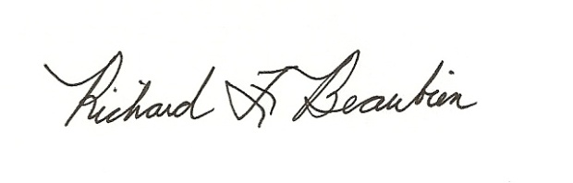
Richard F. Beaubien, P.E., PTOE
Chair-Southeast Michigan Regional Transportation Operations Coordinating Committee

pc: All present

