MEETING MINUTES
SOUTHEAST MICHIGAN REGIONAL TRANSPORTATION OPERATIONS
COORDINATING COMMITTEE

Date: October 22, 2021
Time: 9:00 AM
Meeting Held: SE Michigan Transportation Operations Center in Detroit

Freeway and Arterial Operations Update

Sarah Gill from MDOT reported on freeway and arterial operations issues. Construction on the Segment 3 portion of I-75 will continue into November. Progress has been delayed by the availability of bridge beams. Construction activity is planned for I-94 and for I-75 at Springwells.

The Free Press Marathon run stayed on the Detroit side of the river this year because of the complications of border crossings caused by COVID restrictions The SEMTOC Emergency Management Center was used to coordinate traffic control for the event.

The FHWA self-assessment for Metro Detroit Traffic Incident Management is due November 19 this year. MDOT staff will take the lead in responding to the evaluation form questions and provide copies of the draft responses for review by committee members.

Traffic Planning for Detroit Events.

Carl Berry provided the following information:

The Thanksgiving Day Parade in Detroit will use slightly more than 3 miles on Woodward Avenue. Woodward will be blocked for that distance from the evening of November 24 to 2 pm on the 25th.

The Auto Show is expected to return to the City of Detroit in 2022.

Mound Road Reconstruction Smart Work Zone

John Abraham from the Macomb County Department of Roads Explained how the traffic center cameras allowed changes in traffic signal timing during the reconstruction project to facilitate traffic movement.. The cameras help the Roads Department to provides information to the media on traffic conditions during reconstruction. The Innovate Mound Design Build Project will rebuild Mound from M-59 to 15 Mile in 2022. Phase 2 will rebuild Mound from 15 Mile to I-696 in 2023. Acyclica data collection units will provide real time and historical travel times during the rebuild and allow quick traffic signal timing changes. Traffic information will be available to the public via text, email, Facebook, and Twitter.

Plans fo May 2022 Partnering Workshop

Sarah Gill from MDOT reported on the early planning for an in-person workshop to be held in Washtenaw County in May 2022. This half day workshop in intended to share best practices among the various responders. Preliminary planning suggests that the site will be in Michigan Union on the University of Michigan campus the morning of May 24. The program will likely include a panel discussion of how various partners plan for traffic arriving to and departing from University of Michigan football games.

ITS Canada 2022

John Peracchio from Peracchio & Company reported that the ITS Canada meeting will be held in Windsor May 4-6 of 2022. ITS Canada 2022 is the premier in-person ITS conference in Canada and the USA. It is the first in-person annual conference since 2019. It will feature an excellent technical program, an large exhibit floor, on-street demos, and outstanding technical tours. There will be a gala dinner, networking opportunities, sponsorships, and an ITS roundtable with Michigan Department of Transportation, Ontario Ministry of Transportation, City of Windsor, City of Detroit,and Transport Canada.

Fire Service Report

Canton Fire Chief Christopher Stoecklein reported that the fire service is gradually returning to normal operations after the pandemic. Some fire service personnel from the area traveled to New Orleans to help responders there after recent high winds and flooding..

The fire service is finding that fires in electric vehicles are much more difficult to extinguish. Because it takes more water and more time for responders on the site, fire service trucks and responders are not available for other fire service calls. If the responders are on the road longer, they have a longer exposure to potential injury from other traffic on the road.

He noted that MDOT has been working closely with the communities that will be affected by the I-275 reconstruction scheduled for 2022. This advance information is valuable to responders as they plan for construction impacts.

Statewide Traffic Incident Management

Dawn Miller reported on statewide traffic incident management activities.

Statewide TIM Report 10-22-21

MDOT displays local travel information and MDOT safety messages Welcome Center Video Monitor Pilot Program
- Seven monitors of 14 statewide now displaying 30 second Move Over message: Clare, Coldwater, New Buffalo, Dundee, Monroe, Port Huron, and St. Ignace
- Move Over video replays every 9 about minutes
- Vendor funded partnership with

Crash Responder Safety Week (CRSW) – November 8-14, 2021
- Formerly named National Traffic Incident Response Awareness Week (NTIRAW)
- Activities this week will focus on increasing safety awareness of responders working traffic incidents and drivers encountering traffic incidents
- Filmed TIM video on October 11, 2021 at Michigan State Police Precision Drive Unit (driving track)
  - Video captures responders’ experience working a traffic incident when passing traffic does not move over or slow down
  - Agencies participating in video include Michigan State Police, Eaton County Sheriff’s Office, Delta Township Fire Department, Windsor Township Emergency Services, H & H Mobil Towing, and MDOT
  - Voice over safety message added to video about slowing down and moving over
  - Video will be used during CRSW and all year
  - Final video will be less than 1 ½ minutes
- Press conference to be held November 9, 2021 at Delta Township Fire Department
  - Includes speakers from law enforcement, fire, towing, dispatch, transportation and OHSP
  - Demonstration of live traffic incident management activity area

-

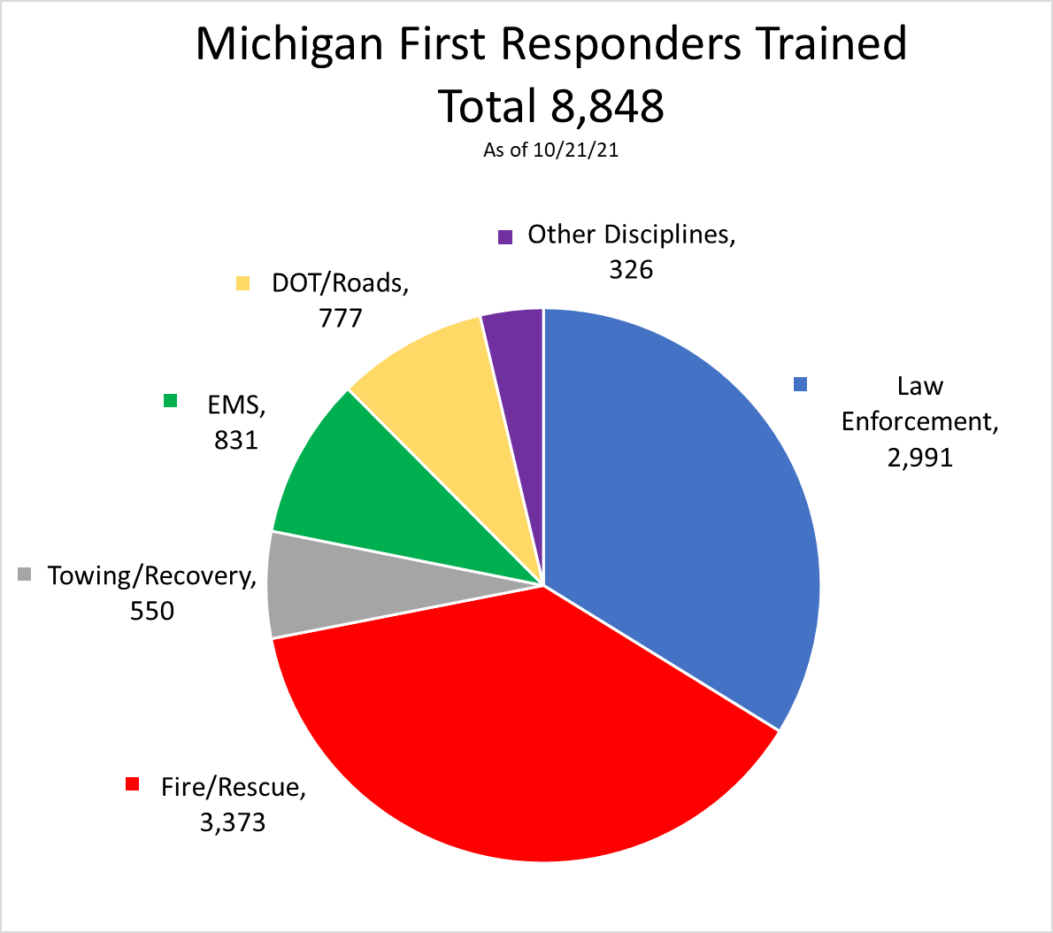

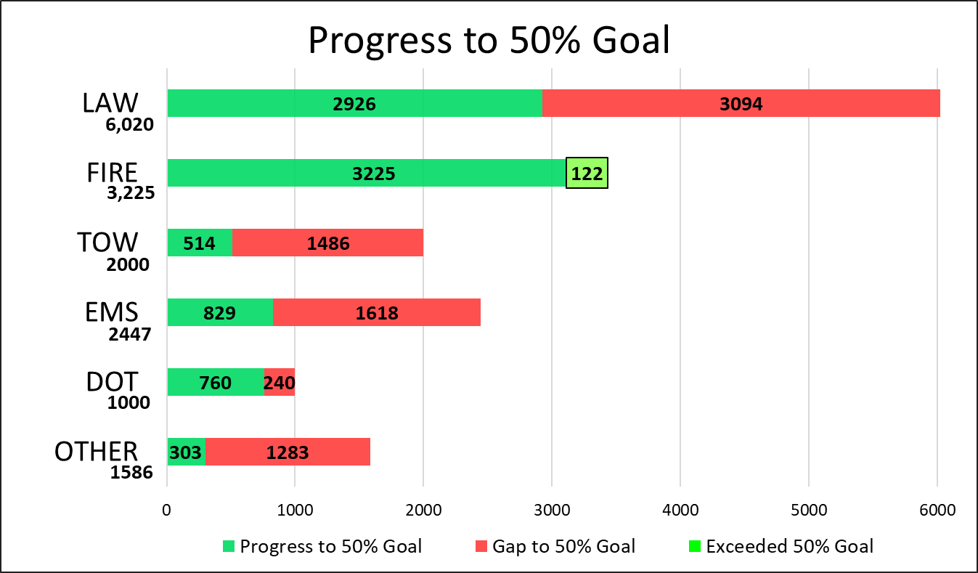

Next TIM Action Team Meeting: December 1, 2021
- Virtual only
- Contact Dawn Miller at millerd2@michigan.gov to be invited to meeting
- Guest speaker (tentative) – Sgt. Bryan Eftink, Auburn Hills Police Department, SOCCIT (Southeast Oakland County Crash Investigation Team)

National Traffic Incident conference at Response Awareness Week - November 7-13, 2021
- Planning for press Delta Township Fire Department
Schedule Mi-TIME classes statewide FHWA Virtual Train the Trainer National Traffic Incident Management Responder Training
- Nationally 4 sessions held in June
- Several new trainers in Michigan

Next Meeting
The next meeting for the Southeast Michigan Regional Transportations Operations Coordinating Committee will be January 21,2022, at the Southeast Michigan Transportation Operations Center if available. These Minutes are intended to be a summary of those items discussed. Any corrections and/or comments should be noted to the writer as soon as possible.

Respectfully submitted,
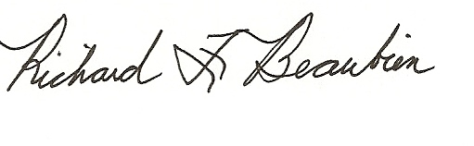
Richard F. Beaubien, PE, PTOE
Chair, SE Michigan Regional Transportation Operations Coordinating Committee

pc: All present

Attendance List
Full Name | Email Address
Dennis Richards | drichards@incidentclear.com
Abraham, John (Macomb Roads) * | jabraham@rcmcweb.org
Carey, Joshua (MDOT) | careyj2@michigan.gov
Carl Berry * | cberry@naiasss.com
Chris Stoecklein (Canton Fire) | christopher.stoecklein@canton-mi.org
Dardzinski, Brian | brian.dardzinski@aecom.com
Herman, Shari (Faith Group) | Shari.herman@faithgroup.com
Dick Beaubien (Beaubien Engineering) | rfbeaubienpe@gmail.com
Gill, Sarah (MDOT) | gills@michigan.gov
Jawad, Ahmad (RCOC) | ajawad@rcoc.org
Perry MacNeille (MacNeille Consulting) | perrymacneille@yahoo.com
Miller, Dawn (MDOT) * | millerd2@michigan.gov
Northern, Donna (Detroit Emerg. Mgmt) | northernd@detroitmi.gov
Martin, Terry (Carrier&Gable) | TerryMartin@carriergable.comCanton Fire
Peracchio, John (Peracchio & Co) * | raymonda2@michigan.gov
Stakleff, Brandon | brandon.stakleff@aecom.com
Swan, Barbara (MDOT) | swanb1@michigan.gov
Tony Geara | gearat@detroitmi.gov

- Virtual participation. (not all virtual participants noted)

