MEETING MINUTES
SOUTHEAST MICHIGAN REGIONAL TRANSPORTATION OPERATIONS
COORDINATING COMMITTEE

Date: July 16, 2021
Time: 9:00 AM
Meeting Held: Virtual Microsoft Team Meeting sponsored by Michigan Department of Transportation

Freeway and Arterial Operations Update

Aaron Raymond from MDOT reported on freeway and arterial operations issues. He reported that freeway traffic volumes had returned to 80% of the level before the pandemic shutdown in March of 2020. There are still traffic incidents on the freeways, and the Freeway Courtesy Patrol is still functioning SEMTOC staff expects to be back in the Traffic Operations Center in August

Barbara Swan reported on two major freeway closure incients.

Report on Road Commission for Oakland County Operations

.Ahmad Jawad reported

Traffic Planning for Detroit Events.

Carl Berry provided notes with the following information:

Motor Bella will be taking place September 21-26 in Pontiac... Public days will be September 23-25. Electric vehicles will be on display. Parking will be on he east side of Woodward. The Oakland County Sheriff will provide the staff for traffic control and operations. Expected attendance is 40,000 per day.

The Auto Show is expected to be back in Detroit next year..

Update on City of Detroit Transportation Operations

Tony Geara from the City of Detroit Traffic Engineering Division reported on Detroit transportation operations. Flooding in the city following the recent rain event has affected traffic signal operations. DTE lost power to more than 200 traffic signals. Some controllers were under water. It may take two weeks to restore power. Bicycle traffic in the city has increased, but pedestrian and bus traffic demand is down. Vehicle traffic has increased slightly. The Detroit Traffic Management Center will be back in the Public Works building shortly.

Fire Service Report

Canton Fire Chief Christopher Stoecklein reported that flooding on the roads has affected fire response.

Report on Virtual Partnering Workshop in May 2021

Aaron Raymond from MDOT reported

Statewide Traffic Incident Management

Dawn Miller reported on statewide traffic incident management activities.

Mi-TIME National Traffic Incident Management Responder Training
- Mi-TIME total training sessions: 399 (most recent 7/2/21)
- Total responders trained: 8679 which is 26.7% of Michigan responders
- Goal: 50% (16,278) of Michigan responders trained by 12/31/22
- Fire/rescue have 51.9% trained, Law enforcement 24.3%, DOT/Roads 38.0%, others less than 20%
- Trainings in 2021: Virtual - 9; In-person trainings – 8 at various Fire Dept and Fire Academy

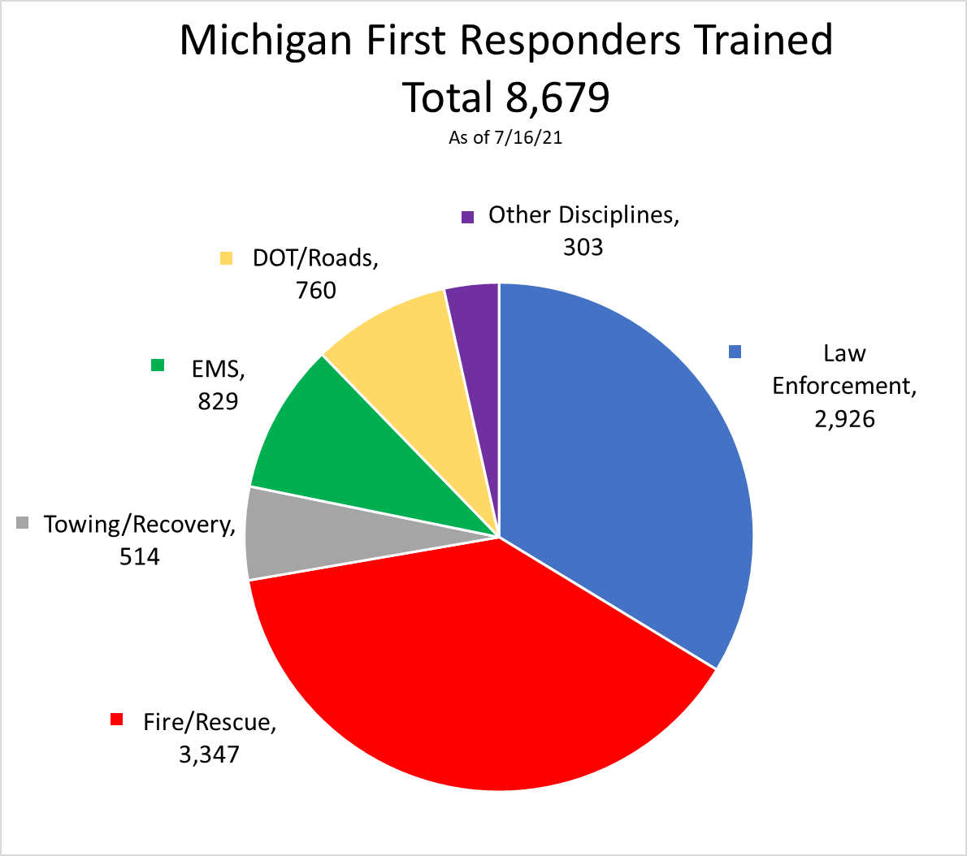

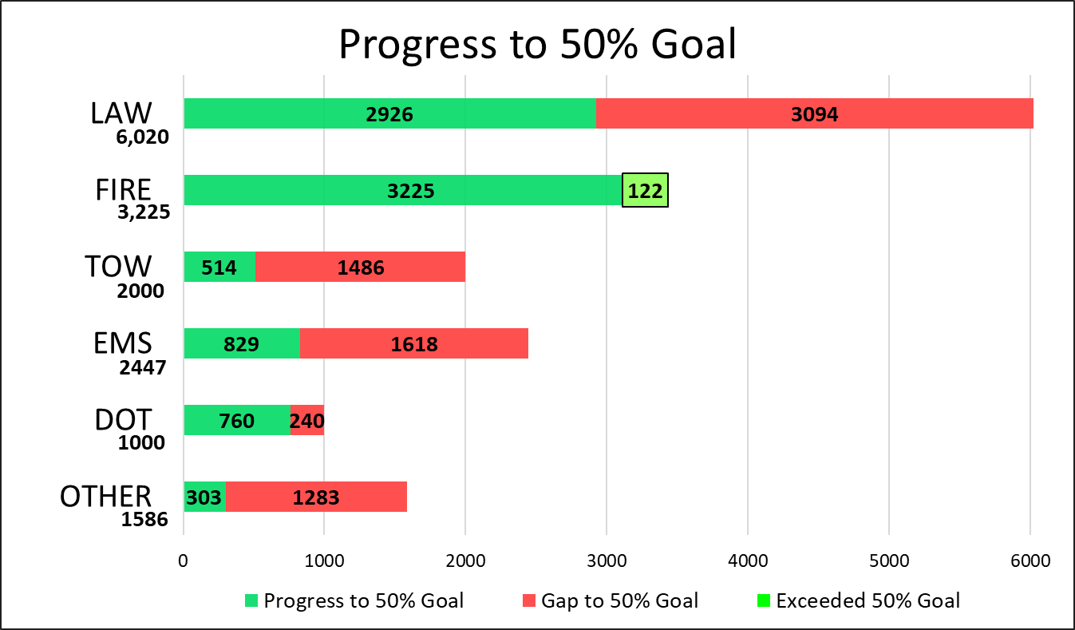

FHWA Virtual Train the Trainer National Traffic Incident Management Responder Training
- Nationally 4 sessions held in June
- Several new trainers in Michigan

Next TIM Action Team Meeting: August 4, 2021
- Guest speaker (tentative) – Sgt. Bryan Eftink, Auburn Hills Police Department, SOCCIT (Southeast Oakland County Crash Investigation Team)
- Planning to meet in person at Horatio Earle Center in Lansing with Teams virtual option
- Contact Dawn Miller at millerd2@michigan.gov to be invited to meeting

National Traffic Incident Response Awareness Week - November 7-13, 2021
- Planning for press conference at Delta Township Fire Department
- Schedule Mi-TIME classes statewide

Next Meeting
The next meeting for the Southeast Michigan Regional Transportations Operations Coordinating Committee is will be October 22, 2021 at the Southeast Michigan Transportation Operations Center if available. These Minutes are to be a summary of those items discussed. Any corrections and/or comments should be noted to the writer as soon as possible.

Respectfully submitted,
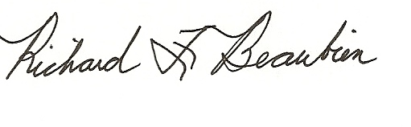
Richard F. Beaubien, PE, PTOE
Chair, SE Michigan Regional Transportation Operations Coordinating Committee

pc: All present

Attendance List
Full Name | Email Address
+1 313-477-3419
+1 734-756-1065
Abraham, John (Macomb Roads) | jabraham@rcmcweb.org
Al-Akash, Mohammad (MDOT-Contractor) | alakashm@michigan.gov
Carey, Joshua (MDOT) | careyj2@michigan.gov
Carl Berry | cberry@naiasss.com
Chris Stoecklein (Guest) | christopher.stoecklein@canton-mi.org
Cox, Kelsey (MDOT) | coxk5@michigan.gov
Dardzinski, Brian | brian.dardzinski@aecom.com
Day, Caitlin (MDOT) | dayc1@michigan.gov
Dick Beaubien (Guest) | rfbeaubienpe@gmail.com
Donna Northern-Detroit HSEM (Guest) | northernd@detroitmi.gov
Gill, Sarah (MDOT) | gills@michigan.gov
Jawad, Ahmad | ajawad@rcoc.org
John Carrier (Guest) | John@carriergable.com
Jones, Rachel | rjones@rcoc.org
Ken Kucel, Detroit-Mayor's Office (Guest) | kucelk@detroitmi.gov
Liu, Luke | yliu@a2gov.org
Miller, Dawn (MDOT) | millerd2@michigan.gov
Nelson, Meredith (MDOT) | nelsonm21@michigan.gov
Ramsden, Benjamin (MSP) | ramsdenb@michigan.gov
Raymond, Aaron (MDOT) | raymonda2@michigan.gov
Sanford, John (MDOT) | sanfordj@michigan.gov
Spencer, Rebecca (MDOT) | spencerr5@michigan.gov
Stakleff, Brandon | brandon.stakleff@aecom.com
Swan, Barbara (MDOT) | swanb1@michigan.gov
Tom Bruff, SEMCOG | bruff@semcog.org
Tony Geara | gearat@detroitmi.gov
Williams, Chris | cwilliams@semcog.org
Wood, Jeffrey (MDOT) | woodj4@michigan.gov
Yang, Qingyan (Ken) | kyang@aecom.com
Young, Jeff | youngj@wcroads.org

Swan, Barbara (MDOT)
William Hayes
Dennis Richards
Carl Berry (Guest)
Miller, Dawn (MDOT)
Yang, Qingyan (Ken)
Raymond, Aaron (MDOT)
Christopher Stoecklein
Dick Beaubien (Guest)
Stakleff, Brandon
Al-Akash, Mohammad (MDOT-Contractor)
Gill, Sarah (MDOT)
Ramsden, Benjamin (MSP)
Day, Caitlin (MDOT)
Carey, Joshua (MDOT)
Webb, Kimberly (MDOT)
Jawad, Ahmad
Ken Kucel, Mayor's Office (Guest)
Wood, Jeffrey (MDOT)
Dardzinski, Brian
Steven Lavrenz
Carl Berry
Cox, Kelsey (MDOT)
Liu, Luke
Tony Geara
John Abraham
Geara, Tony
Spencer, Rebecca (MDOT)

