MEETING MINUTES
SOUTHEAST MICHIGAN REGIONAL TRANSPORTATION OPERATIONS
PLANNING SUBCOMMITTEE

Date: February 9, 2016
Time: 10:00 AM
Meeting Held: SE Michigan Transportation Operations Center, 1060 W. Fort Street, Detroit MI 48226

Present: Representing Phone No. E-Mail

Dayo Akinyemi………. …MDOT - SEMTOC…....(313) 256-9802………..…AkinyemiO@michigan.gov
John Abraham……...… Macomb Dept. Roads … ...(586) 493-6701……………..jabraham@rcmcweb.org
Tom Bruff…….. …..……… SEMCOG……...... (313) 324-3340.…....................bruff@semcog.org
Walter Ison…………………..MDOT .............. (248) 910-3529……..…isonw@michigan.gov
Sarah Gill……………....MDOT – SEMTOC..…….(248) 867-6841…………………gills@michigan.gov
Dawn Miller……………………..MDOT…………..(517) 636-4719……………millerd2@michigan.gov DonnaNorthern……….Detroit Homeland Sec……...(313)596-6558………...….northernd@detroitmi.gov
Nathan Ross………………...SEMTOC…………….(248) 867-4765……………..…rossn@michigan.gov
Chris Williams……………..SEMCOG…. …………(313) 407-4211…………….cwilliams@semcog.org
Richard Beaubien Beaubien Engineering ..(248) 515-3628 …rfbeaubienpe@gmail.com

Plans for 2016 Partnering Workshop
The City of Detroit Homeland Security will be hosting an incident management workshop on March 14, 2016 at Comerica Park. Topics for this workshop include the citywide evacation plan to be presented by Walter Davis and the traffic operations plan for the entertainment complex surrounding the new hockey arena presented by Rick Fenton. The operations of the Macomb County Traffic Operations Center and Emergency Management and the role of the medical examiner in quick clearance will also be discussed. A panel discussion of HAZMAT response will include representatives from Troy Fire Department, Michigan Department of Environmental Quality, and Terra Contracting. MDOT Region Engineer Tony Kratofil will provide a presentation on Metro Detroit Regional Transportation Operations and Innovations.

The Michigan Department of Transportation agreed to provide a photographer for the event. Meeting registration is on the ITS Michigan website. We will plan for 150 attendees. To date there are 88 registrants. Belinda Beard will prepare name tags and table assignments on behalf of ITS Michigan. Two or three staff people from the City Detroit will be needed to assist her with registration on the day of the event. Sarah Gill will finalize the speakers for the luncheon program on lessons learned from major freeway incidents by the end of the week. MDOT and SEMCOG will bring audio visual equipment to the event to enable presentations. Sarah Gill will be meeting with the Hazmat panel within the next two weeks to organize that discussion.

Richard Beaubien will provide the list of current registants to Donna Northern and Sarah Gill so that individuals who need to register can be identified. Chris Williams will provide a list of handouts for the meeting. The deadline for presentations to be provided to Tom Bruff at SEMCOG is March 7.

This event will be accompanied by an afternoon traffic incident management responder training session from 1 pm to 5 pm. This second event is planned for 40 attendees.

Next Planning Subcommittee Meeting
The next regular meeting for the Planning Subcommittee has been scheduled for 11:00 AM on February 29, 2016 at the Tiger Club at Comerica Park to finalize the logistics of the March 14 program.

These minutes are intended to be a summary of those items discussed. Any corrections and/or comments should be noted to the writer as soon as possible.

Respectfully submitted,

BEAUBIEN ENGINEERING

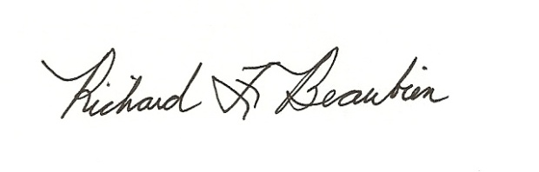
Richard F. Beaubien, P.E., PTOE
Chair-Southeast Michigan Regional Transportation Operations Coordinating Committee

pc: All present

