MEETING MINUTES
SOUTHEAST MICHIGAN REGIONAL TRANSPORTATION OPERATIONS
PLANNING SUBCOMMITTEE

Date: October 2, 2014
Time: 9:00AM
Meeting Held: Southeast Michigan Transportation Operations Center, Detroit

Present: Representing Phone No. E-Mail

Dayo Akinyemi………. …MDOT - SEMTOC…....(313) 256-9802…………AkinyemiO@michigan.gov
Morrie Hoevel……….. ...….. … . FHWA… ……. 517) 702-1834…………..…Morris.Hoevel@dot.gov
Belinda Beard…… ……………PB/ITSMI….…….(313) 202-1163…… …………beard@pbworld.com
Craig Shackleford…… Bloomfield Twp. Police (248) 433-7749 ……….cshackleford@bloomfiedtwp.org
Tom Bruff…….. …..……… SEMCOG…….... (313) 324-3340.…....................bruff@semcog.org
Richard Beaubien Beaubien Engineering (248) 515-3628 …rfbeaubienpe@gmail.com

Review of Meeting Agenda for the Southeast Michigan Regional Transportation Operations Coordinating Committee Meeting
The October 24, 2014 Regional Transportation Operations Coordinating Committee meeting will be held at the Southeast Michigan Transportation Operations Center (SEMTOC), 1060 West Fort Street, Detroit, Michigan 48226. Potential topics will include, SCATS Adaptive Traffic Signal Update, regional transportation operations goals and objectives, transit system fare integration, a review of the ITS World Congress TIM demonstration, freeway operations, advanced telemedicine, and a review of statewide traffic incident management activities.

Regional Concept of Transportation Operations Goals & Objectives
Tom Bruff has reviewed the goals and objectives resulting from the Regional Concept of Transportation Operations process. Some of the objectives have been achieved. Other obectives and tasks need to be reassessed and/or reassigned. He will begin a discussion of this review at the October 24 Coordinating Committee meeting to achieve a concensus on which goals and objectives need to be revised.

Plans for 2015 Partnering Workshop
The workshop is tentatively scheduled for March 5, 2015. Possible locations include Wayne County Community College, AAA Michigan Headquarters, and Oakland County Executive Offices. Richard Beaubien will investigate potential locations and develop a recommendation for consideration in advance of the October 24 Coordinating Committee meeting.

There was a consensus that interactive sessions such as conversation circles or table top excercises would be welcomed by first responders and other participants. A conversation involving emergency management, traffic operations, county roads, fire service, police, and tow service would be helpful. Potential discussion topics included after action review lessons learned, uses for probe data (Jason Firman), next generation 911, MiTIME training promotion, uses for unmanned aerial vehicles in traffic incident management, lessons learned from the bridge collapse on the Southfield Freeway (M-39). Dayo Akinyemi will check with Mike Gorman to determine whether this would be a suitable topic for presentation and discussion of lessons learned by the various first responders. Both MDOT video and broadcast media video of this incident may be available to stimulate and inform the discussion.

Next Planning Subcommittee Meeting
The next meeting for the Planning Subcommittee has been scheduled for 8:30 AM on December 1, 2014 at SEMTOC.

These minutes are intended to be a summary of those items discussed. Any corrections and/or comments should be noted to the writer as soon as possible.

Respectfully submitted,

BEAUBIEN ENGINEERING

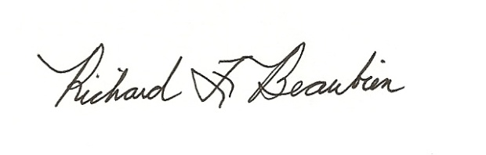
Richard F. Beaubien, P.E., PTOE
Chair-Southeast Michigan Regional Transportation Operations Coordinating Committee

pc: All present

