MEETING MINUTES
SOUTHEAST MICHIGAN REGIONAL TRANSPORTATION OPERATIONS
PLANNING SUBCOMMITTEE

Date: March 20, 2014
Time: 2:30 PM
Meeting Held: Macomb County Communications and Technology Center, Mt. Clemens, MI

Present: Representing Phone No. E-Mail

Jonathan Coleman….. …URS@MCDRTOC…...(586) 506-6824………………jcoleman@rcmcweb.org
Dawn Miller……….. ... MDOT… …….. (517) 636-4719 …………..…millerd2@michigan.gov
Tom Bruff……………………SEMCOG…………(313) 324-3340…… ………. bruff@semcog.org
Craig Shackleford…… Bloomfield Twp. Police (248) 433-7749 ……….cshackleford@bloomfiedtwp.org
Adam Merchant…….. … Macomb DOR……. (586) 463-8671.…..............amerchant@rcmcweb.org
Kelly Marthen….….Bloomfield Twp. Police….(248)433-7749………kmarthen@bloomfieldtwp.org
Richard Beaubien Beaubien Engineering (248) 515-3628 …rfbeaubienpe@gmail.com

Review of Meeting Agenda for the Southeast Michigan Regional Transportation Operations Coordinating Committee Meeting
The April 4, 2014 Regional Transportation Operations Coordinating Committee meeting will be held at the Southeast Michigan Transportation Operations Center (SEMTOC), 1060 West Fort Street, Detroit, Michigan 48226. Potential topics will include, a review of the March 20 Partnering Workshop led by Tom Bruff, a Train the Trainer module on the anatomy of a traffic incident, a Transportation Research Board presentation on traffic incident management progress, freeway operations, and a review of statewide traffic incident management activities.

Review of Partnering Workshop in March 2014
The workshop was conducted March 20 at Macomb Community College. Both County Executive Mark Hackel and Emergency Operations Manager Vicki Wolber explained the planning and operation of the new center. Sheriff Wickersham and County Roads and County Highway Engineer Bob Hoepfner were on a panel discussing how traffic cameras, sheriff dispatch, and emergency management operate in an integrated fashion.

Other topics included in the program included fire service traffic incident management concerns and the I-696 Integrated Corridor Management projects. Ellen Fleming from Beaumont Medical Transportation discussed the role of Emergency Medical responders. Tours of the Operations Center were available after lunch. Presentations were stored on Tom Bruff’s computer. MDOT arranged for a photographer.

Macomb County Community College campus maps should have been provided to registrants in advance of the workshop to help them find the correct building on the morning of the 20th. Overall comments on the workshop were very favorable. Several attendees noted similarities between this year’s program and last year’s program. Disciplines represented at the workshop included automotive, consulting, dispatch, emergency management, EMS, fire, Homeland Security, law enforcement, towing, and planning.

Next Planning Subcommittee Meeting
The next meeting for the Planning Subcommittee has been scheduled for 2 PM on June 19, 2014 at SEMTOC.

These minutes are intended to be a summary of those items discussed. Any corrections and/or comments should be noted to the writer as soon as possible.

Respectfully submitted,

BEAUBIEN ENGINEERING

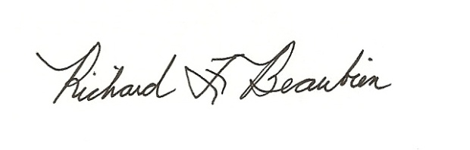
Richard F. Beaubien, P.E., PTOE
Chair-Southeast Michigan Regional Transportation Operations Coordinating Committee

pc: All present

