MEETING MINUTES
SOUTHEAST MICHIGAN REGIONAL TRANSPORTATION OPERATIONS
PLANNING SUBCOMMITTEE

Date: December 12, 2013
Time: 2:00 PM
Meeting Held: Macomb County Department of Roads, Mt. Clemens, MI

Present: Representing Phone No. E-Mail
Oladayo Akinyemi MDOT - SEMTOC (313) 256-9802 AkinyemiO@michigan.gov
Belinda Beard …………… ITSM-PB…… .... (313) 202-1163 …………………beard@pbworld.com
Morrie Hoevel FHWA (517) 702-1834 Morris.Hoevel@dot.gov
Craig Shackleford…… Bloomfield Twp. Police (248) 433-7749 …….cshackleford@bloomfiedtwp.org
Kelly Marthen…….. Bloomfield Twp. Police… (248) 433-7758.…...kmarthen@bloomfieldtwp.org
Richard Beaubien Beaubien Engineering (248) 515-3628 rfbeaubienpe@gmail.com

Review of Meeting Agenda for the Southeast Michigan Regional Transportation Operations Coordinating Committee Meeting
The January 10, 2014 Regional Transportation Operations Coordinating Committee meeting will be held at the Southeast Michigan Transportation Operations Center (SEMTOC), 1060 West Fort Street, Detroit, Michigan 48226. Potential topics include a presentation on the AAA Tow Service program, a review of progress on 2013 goals and objectives led by Tom Bruff, a report on Arterial Traffic Management, freeway operations, and a review of statewide traffic incident management activities. A recap of the Homeland Security tabletop exercise for Detroit may be available for this meeting.

Plans for Partnering Workshop in March 2014
The workshop is scheduled for March 20 at Macomb Community College. We would hope that both County Executive Mark Hackel and Emergency Operations Manager Vicki Wolber would be available to explain the planning and operation of the new center. Sheriff Wickersham and County Roads could be on a panel discussing how traffic cameras, sheriff dispatch, and emergency management operate in an integrated fashion.

Other potential topics to include in the program included the Mutual Aid Box Alarm system, and the I-696 Integrated Corridor Management projects. Laurie Thiel recommended a Ellen Fleming from Beaumont Medical Transportation to discuss the role of Emergency Medical responders. Because the Operations Center is limited to 50 attendees, we will try to arrange to use the Macomb Community College facilities for the presentations and offer tours of the Operations Center after lunch. During workshop registration, tour times could be assigned, and maps to the Operations Center could be distributed. Parking limitations at Macomb County Roads may necessitate transit or shared rides to access the tour.

SEMCOG will arrange for the preparation of the program and the collection of speaker biographies and presentations. MDOT will arrange for a photographer.

Hold Harmless Legislation
MDOT has drafted a bill to be considered by the legislature, and the draft is circulating for comments. MDOT is still working with its partners to get more buy in before the bill is introduced. MDOT and SEMCOG will be meeting with AAA Michigan in January.

Next Planning Subcommittee Meeting
The next meeting for the Planning Subcommittee has been scheduled for 9 AM on February 13, 2014 at Macomb County Roads. It will focus March 2014 Partnering Workshop in Macomb County These minutes are intended to be a summary of those items discussed. Any corrections and/or comments should be noted to the writer as soon as possible.

Respectfully submitted,

BEAUBIEN ENGINEERING

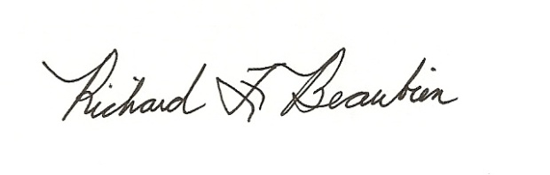
Richard F. Beaubien, P.E., PTOE
Chair-Southeast Michigan Regional Transportation Operations Coordinating Committee

pc: All present

