MEETING MINUTES
SOUTHEAST MICHIGAN REGIONAL TRANSPORTATION OPERATIONS
PLANNING SUBCOMMITTEE

Date: December 18, 2012
Time: 9:00 AM
Meeting Held: Road Commission for Oakland County Traffic Operations Center, Pontiac, Michigan

Present: Representing Phone No. E-Mail
Oladayo Akinyemi MDOT SEMTOC (313) 256-9800 AkinyemiO@michigan.gov
Brandon Boatman MDOT (517) 636-4719 BoatmanB@michigan.gov
Tom Bruff SEMCOG (313) 324-3340 bruff@semcog.org
Morrie Hoevel FHWA (517) 702-1834 Morris.Hoevel@dot.gov
Craig Shackelford…… Bloomfield Twp. Police (248) 433-7749 …….cshackelford@bloomfiedtwp.org
Matt Hill……………… Bloomfield Twp. Police (248) 433-7758 …….………mhill@bloomfieldtwp.org
Ahmad Jawad……….. Rd. Comm. Oakland Co (248) 858-7250…………………… ajawad@rcoc.org
Richard Beaubien Beaubien Engr (248) 515-3628 rfbeaubienpe@gmail.com

Tour of Road Commission for Oakland County Traffic Operations Center

Ahmad Jawad described the FAST-TRAC system monitored at the Road Commission’s Traffic Operations Center. The system controls 700 traffic signals equipped with SCATS signal controllers. This is the largest adaptive traffic signal system in North America. The system uses 2500 intersection cameras to provide detection for the adaptive traffic signal controllers by approach and by lane of approach. The adaptive nature of the system allows traffic signal timing to be changed dynamically, in response to travel demand. The system reduces travel delays by 25% during the off-peak period and by 7% in the peak period of travel. The Road Commission’s Traffic Operations Center has access to the MDOT freeway camera images.

Review of Meeting Agenda for the Southeast Michigan Regional Transportation Operations Coordinating Committee Meeting
The January 11, 2013 Regional Transportation Operations Coordinating Committee meeting will be held at the new Southeast Michigan Transportation Operations Center (SEMTOC), on Fort Street, immediately south of the current MITSC building, Detroit, Michigan 48226. It will include a presentation on GM OnStar communications with first responders, a report on the Oakland Incident Management Team, and a review of statewide traffic incident management activities. It will also include a review of freeway operations issues.

March Partnering Workshop
The Annual Traffic Incident Management Workshop is scheduled for March 7, 2013 at the Southeast Michigan Transportation Operations Center. Dayo Akinyemi indicated that the attendance in his facility will be limited to 100 people. The suggested program will include:

- Tour of the Southeast Michigan Transportation Operations Center
- Presentation by Michigan State Police on their regional dispatch operation
- Presentation on the Freeway Courtesy Patrol
- Presentation on Medical Examiner Quick Clearance Issues
- Presentation by Macomb County Executive Mark Hackel on the County Emergency Operations Center
- Fire Service Incident Command for the I-696/Halstead tanker rollover
- Presentation by Angie Kremer on SHRP-2 Traffic Incident Management Training

Registration for the workshop will be available on the SEMCOG website. An announcement of the workshop should be sent to the SE Michigan Fire Chiefs, American Public Works Association, ITS Michigan, Institute of Transportation Engineers, and Medical Examiners. SEMCOG will prepare the workshop agendas and handout information. Each presentation should have a theme. Speakers will be asked to address the question, “What can we improve in the future?” Tom Bruff will check on prices for continental breakfast and box lunch service. Dayo Akinyemi will arrange for the rental of round tables. The estimated table cost rental is in the $100 - $150 range.

Next Planning Subcommittee Meeting
The next meeting for the Planning Subcommittee will be held at 10:30 AM on January 11, 2013, following the Coordinating at SEMTOC. These minutes are intended to be a summary of those items discussed. Any corrections and/or comments should be noted to the writer as soon as possible.

Respectfully submitted,

BEAUBIEN ENGINEERING

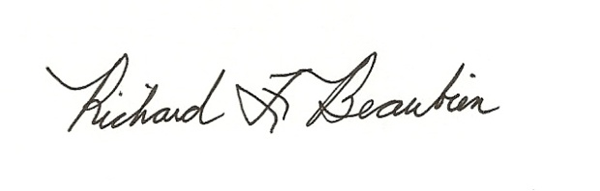
Richard F. Beaubien, P.E., PTOE
Chair-Southeast Michigan Regional Transportation Operations Coordinating Committee

pc: All present

