MEETING MINUTES
SOUTHEAST MICHIGAN REGIONAL TRANSPORTATION OPERATIONS
PLANNING SUBCOMMITTEE

Date: November 8, 2012
Time: 9:00 AM
Meeting Held: Southeast Michigan Regional Transportation Operations Center, Detroit, Michigan

Present: Representing Phone No. E-Mail
Oladayo Akinyemi MDOT MITSC (313) 256-9800 AkinyemiO@michigan.gov
Ola Williams MDOT (517) 241-1237 williamso2@michigan.gov
Phil Wagner Board-Up (248) 433-7749 cschackelford@bloomfieldtwp.com
Morrie Hoevel FHWA (517) 702-1834 Morris.Hoevel@dot.gov
Richard Beaubien Beaubien Engr (248) 515-3628 rfbeaubienpe@gmail.com

Review of Meeting Agenda for the Southeast Michigan Regional Transportation Operations Coordinating Committee Meeting
The January 11, 2013 Regional Transportation Operations Coordinating Committee meeting will be held at the new Southeast Michigan Transportation Operations Center (SEMTOC), on Fort Street, immediately south of the current MITSC building, Detroit, Michigan 48226. It will include a presentation on Integrated Corridor Management for I-75, a Chiefs of Police video on traffic incident management, a report on the Oakland Incident Management Team, and a review of statewide traffic incident management activities. It will also include a review of freeway operations issues.

March Partnering Workshop
The Annual Traffic Incident Management Workshop is scheduled for March 7, 2013 at the Southeast Michigan Transportation Operations Center. Dayo Akinyemi indicated that the attendance in his facility will be limited to 100 people. The suggested program topics included:

- Tour of the Southeast Michigan Transportation Operations Center
- Presentation by Michigan State Police on their regional dispatch operation
- Presentation on the Freeway Courtesy Patrol
- Presentation on Medical Examiner Quick Clearance Issues
- Presentation of Incident Command for Public Works
- Presentation by City of Monroe Mayor Bob Clark on Traffic Incident Management
- Presentation by Macomb County Executive Mark Hackel on the County Emergency Operations Center
- Presentation by Angie Kremer on SHRP-2 Traffic Incident Management Training
- Presentation on Emergency Medical Services

Next Planning Subcommittee Meeting
The next meeting for the Planning Subcommittee will be held at 9:00 AM on December 18, 2012 at the Road Commission for Oakland County Traffic Operations Center, 1200 N. Telegraph, Building W49. These minutes are intended to be a summary of those items discussed. Any corrections and/or comments should be noted to the writer as soon as possible.

Respectfully submitted,

BEAUBIEN ENGINEERING

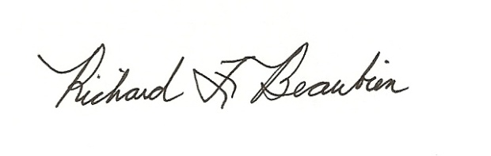
Richard F. Beaubien, P.E., PTOE
Chair-Southeast Michigan Regional Transportation Operations Coordinating Committee

pc: All present

